1. Using nested JSX more than one element, wrap it with one container element use div as a container element which has three nested elements inside it.

Create an application to create your address and personal details.

import React from "react";

function App() {

  return (

    <div className="App" style={{ margin: "20px" }}>

      <form>

        <label>name:-</label>

        <input type="name" placeholder="Enter your name" />

        <br />

        <label>enter adress:-</label>

        <br />

        <textarea

          id="address"

          rows="4"

          cols="50"

          placeholder="Enter your address"

        ></textarea>

        <br />

        <label>phone:-</label>

        <input type="text" placeholder="Enter your Phone number" />

        <br />

        <label>email:-</label>

        <input type="email" placeholder="Enter your Email" />

        <br />

      </form>

    </div>

  );

}

export default App;

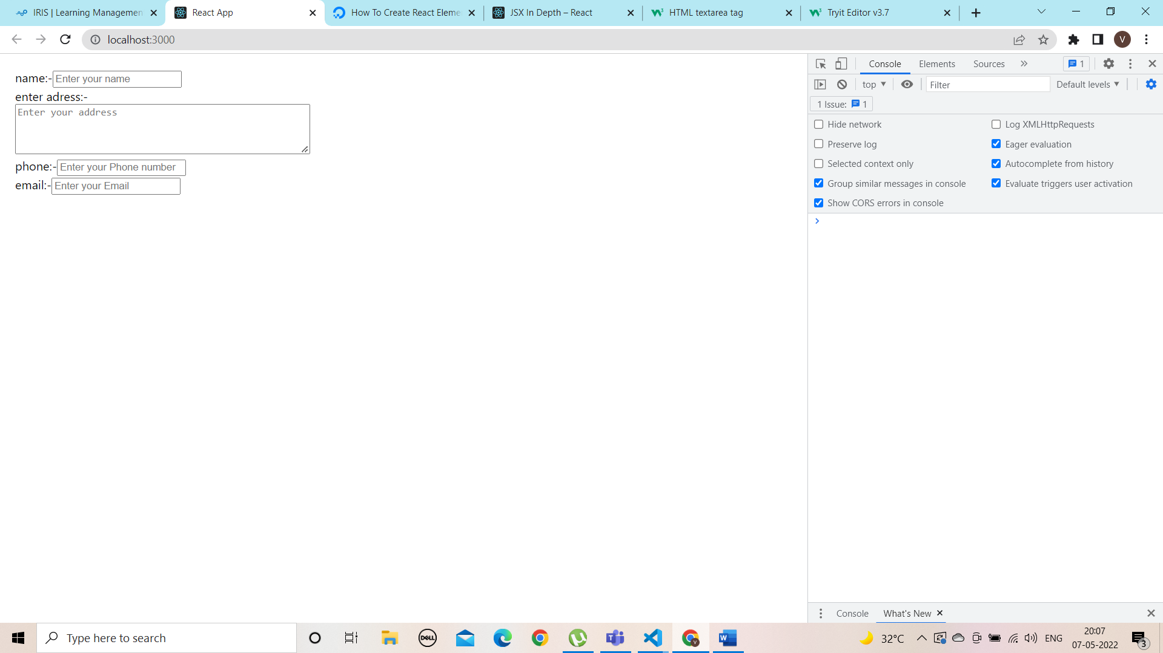

2. Create a contact class and extends component and display your contact details like email, phone no

import React from "react";

class Contact extends React.Component {

  constructor(props) {

    super(props);

    // We declare the state as shown below

    this.state = {

      Email: "Name@mindtree.com",

      Phone: "9876543210",

    };

  }

  render() {

    let Email1 = this.state.Email;

    let Phone1 = this.state.Phone;

    return (

      <div>

        <h2>Contact details are:-</h2>

        <h3>email :- {Email1}</h3>

        <h3>Phone no :-{Phone1}</h3>

      </div>

    );

  }

}

export default Contact;

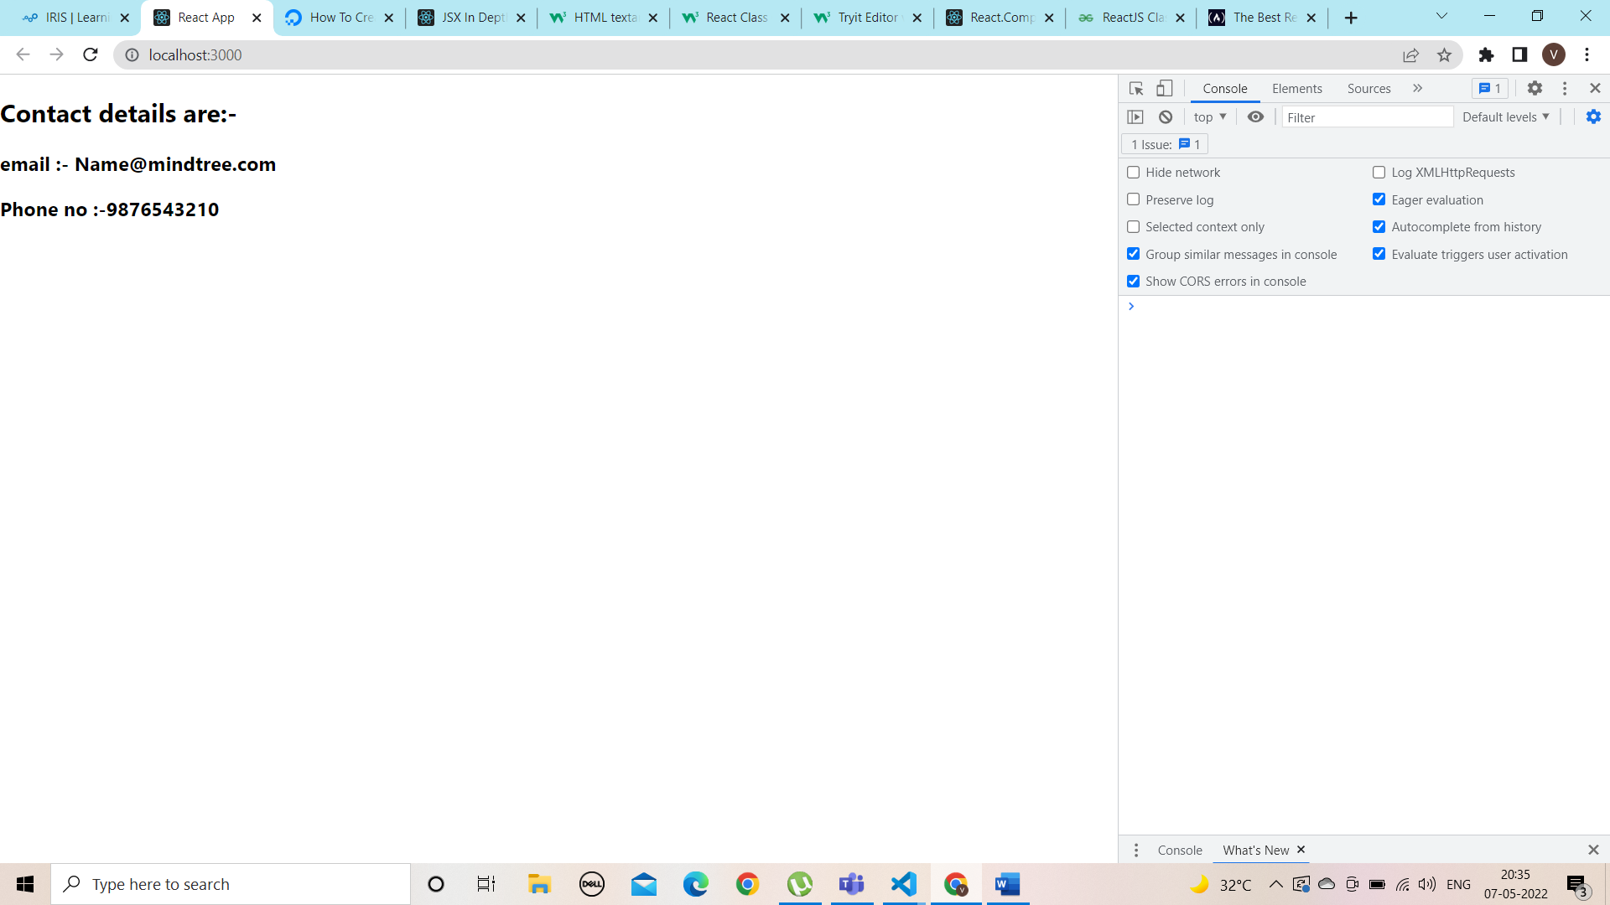

3. Create a employee class and extends component and display your details like address, salary and emailed using CSS in react

import React from "react";

class App extends React.Component {

  constructor(props) {

    super(props);

    // We declare the state as shown below

    this.state = {

      Address: "xyz village, ABC mandal, pqr district",

      Salary: "50,000",

      Email: "XYZ@mindtree.com",

    };

  }

  render() {

    let Address1 = this.state.Address;

    let Salary1 = this.state.Salary;

    let Email1 = this.state.Email;

    return (

      <div

        style={{

          margin: "250px",

          color: "blue",

          border: "2px solid black",

          padding: "50px",

        }}

      >

        <h2 style={{ color: "red" }}>Contact details are:-</h2>

        <h3>Address :- {Address1}</h3>

        <h3>Salary :-{Salary1}</h3>

        <h3>Email :-{Email1}</h3>

      </div>

    );

  }

}

export default App;

